**PrepInsta Data Structures & Algorithms**

## Searching

**Searching algorithms are easy to learn but are really important for college semester exams and companies offering package between 3 – 6 LPA would ask direct searching questions in online test/ interviews.**

# **Linear Search in Java**

July 26, 2020

## ****What is a linear search?****

**Linear Search is a sequential search algorithm. In Linear Search we’ll have to traverse the array comparing the elements consecutively one after the other until the target value is found. Linear Search has a high time complexity making at most n comparison hence, it is suitable to search for elements in small and unsorted list of elements.**

## ****Implementation of Linear Search****

* **Step 1:** Take the input from the user.
* **Step 2:** Create a function for the search to be carried out.
* **Step 3:** Create a for loop in the above created function that will start from i = 0 to the last index of the array that is Array Length-1.
* **Step 4:** Compare every element with the target element.  
  If element is found return i , where i is the index of searched element.
* **Step 5:** If element is not found after traversing through the list, return -1 with a message of unsuccessful search.

## ****Algorithm to implement linear search in JAVA****

1. int Search(Arr[] , Search Element)
2. FOR i = 0, i -> Arr[].length
3. IF (Arr[i] == Search Element)  
   return i;
4. END of FOR
5. return -1

## Program to implement linear search algorithm in JAVA

import java.util.*;

public class Main

{

public static int search(int ar[], int s)

{

int l = ar.length;

for(int i = 0; i < l; i++)

{

if(ar[i] == s)

return i;

}

return -1;

}

public static void main(String args[])

{

int ar[] = { 2, 3, 4, 10, 40 };

System.out.println("Enter a number you want to search for - ");

Scanner s= new Scanner(System.in);

int num=s.nextInt();

int result = search(ar, num)+1;

if(result == -1)

System.out.print("Element not found.");

else

System.out.print("Element found at index " + result);

}

}

Enter a number you want to search for -

3

Element found at index 2

## Linear Search vs Binary Search

[Binary search](https://prepinsta.com/java-program/binary-search/) is much faster than linear search, while the former has time complexity of Log(n) the later has O(n)



## Time Complexity For Linear Search

## Best

O(1)

## Average

O(n)

## Worst

O(n)

## Space Complexity

O(1)

## Average Comparisions

(N+1)/2

# **Binary Search in JAVA**

July 28, 2020

# **Binary Search in JAVA**

**Binary search is a searching technique that is based upon the Divide-and-Conquer Rule. In this searching technique, a sorted array is divided into two equal halves and then the same technique is applied onto the two halves searching for the element by comparing the high and the low.**

## Working of binary search in JAVA

1. For Binary Search to be performed on any array, the array must be already sorted in any format, that is, either ascending or descending.
2. Find the middle index of the array/list.
3. If the middle element is equal to the search element, Stop Searching.
4. If the element that is to be searched is less then the middle element then consider the first half as a separate list.
5. Else-If the element that is to be searched is larger then the middle element then consider the second half as a separate list.
6. Repeat Step 2-3-4-5 Until desired result is found.

## Algorithm of Binary Search in JAVA

* while(low<=high)  
        mid=(low+high)/2;
* if(a[mid]<search_element)  
        low=mid+1;
* else if(a[mid]>search_element)  
        high=mid-1;
* If found return index
* Else return -1

## Program of Binary Search in JAVA

import java.util.*;

class Main {

int search(int arr[], int x)

{

int l = 0, r = arr.length - 1;

while (l <= r) {

int m = l + (r - l) / 2;

if (arr[m] == x) //if x is in the middle

return m;

if (arr[m] < x) //if x is greater, search the right half

l = m + 1;

else //if x is smaller, search the left half

r = m - 1;

}

return -1; //not found

}

public static void main(String args[])

{

Main s=new Main();

Scanner sc= new Scanner(System.in);

System.out.println("Enter the element to be searched ");

int num=sc.nextInt();

int arr[]={3,5,6,7,10,14,15,75,88,96,99};

int result = s.search(arr, num);

if (result == -1)

System.out.println("No match found in the Array");

else

System.out.println("Match found at index " + result);

}

}

Enter the element to be searched

96

Match found at index 9



## Time Complexity For Binary Search

## Best

O(1)

## Average

O(log n)

## Worst

O(log n)

## Space Complexity

O(1)

# **Time Complexities for Placements**

August 17, 2020

Time Complexities for Algorithms-

Atleast 2 Questions from these will be asked in the Exam thus I will suggest you to Mug up these.

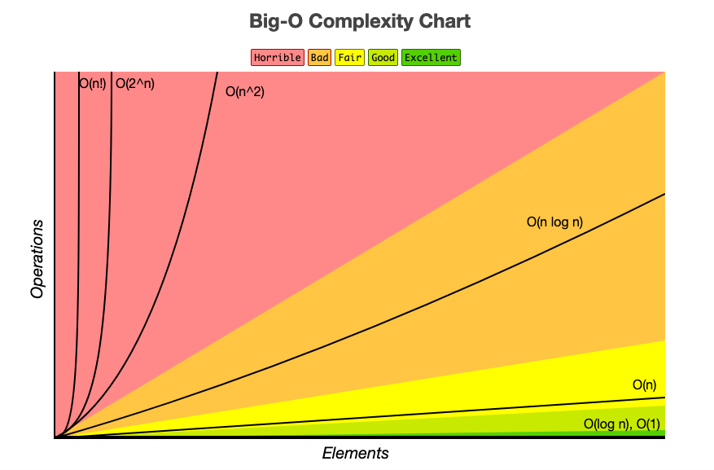

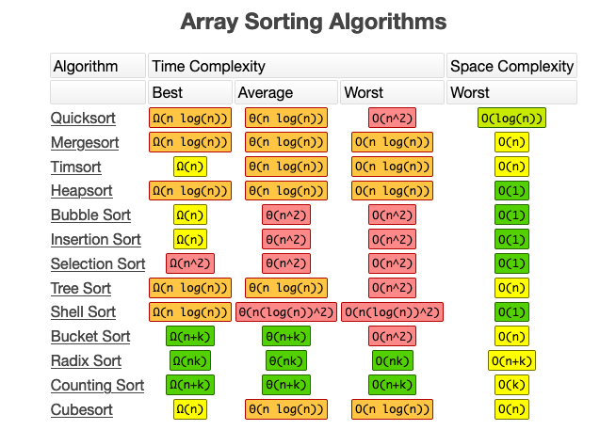

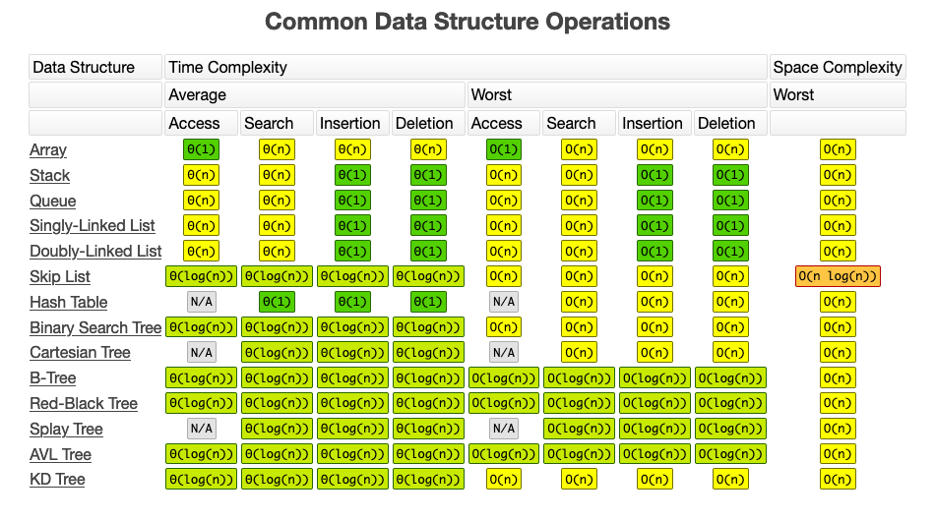

Will Suggest Mugging up till Binary Search Tree the later are optional and asked very very rarely.

# **Searching Meme Review**

July 26, 2020













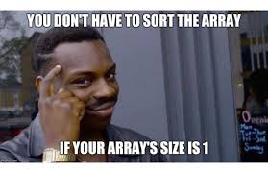

## Sorting

**Sorting algorithms are easy to learn but are really important for college semester exams and companies offering package between 3 – 6 LPA would ask direct searching questions in online test/ interviews.**

# **Classification of Sorting Algorithms**

June 24, 2019

## Stable Vs Unstable Sorting

**Stable sort** sorts the identical elements in their same order as they appear in the input.  
Examples: Bubble sort, Insertion sort, Merge Sort, Counting sort

In ***unstable sort***, order of identical elements is not guranteed to stay in the same order as they appeared in the input. Examples: Quick Sort, Heap Sort, Selection sort

* Stability is not an issue when equal elements are indistinguishable such as with integers.
* Any given sorting algorithm which is not stable can be modified to stable.
* Generally, unstable sorting is faster than stable sorting.
* We need a stable sort to sort the cards by their numbers and suit.

### **Internal Vs External Sort**

***Internal sorting*** is that which takes place entirely within the main memory of computer. It comes into role when the dataset is small.

***External sorting*** is that which can handle massive amount of data at a time. Data reside in hard disk in case of external sorting.

**Comparison based Sorting  and Counting based Sorting**

***In Comparison based sorting,***a comparator is required to compare numbers or items. This comparator defines the ordering to arrange the elements.  
Examples: Merge Sort, Quick Sort, Heap Sort

***Counting based sorting***is the algorithm that perform the sorting without comparing the elements rather by making certain assumption about the data they are going to sort.  
Examples: Counting sort, Radix sort

### **In-Place and Not-In-Place Sorting**

***In-Place Sorting***means to sort the array by modifying the element order directly within the array.

* No auxiliary data structure is used.
* There can be only constant amount of extra space usually less than log(n). So this algorithm is space efficient.

Examples: Bubble Sort, Selection Sort, Insertion Sort, Heap Sort

***Not-In-Place Sorting***is that which uses auxiliary data structure to sort the array.  
Examples: Merge Sort ( It requires additional O(n) space to perform the merge operation), Quick Sort

# **Bubble Sort in Java**

July 26, 2020

## What is Bubble Sort in JAVA?

**Bubble Sort is the elementary sorting algorithm for sorting various data structure. It is a comparison based sorting algorithm in which each element is compared with the next element, and is swapped if those elements are not in the correct order.**

* **The algorithm starts with comparing the first pair of elements.**
* **If the first element is smaller then the second element, then the elements are interchanged, otherwise the order remains intact.**
* **This algorithm is not suitable for large data sets**

## Implementation of bubble sort in JAVA

* First we will take starting two elements from the list.
* Then we will compare those elements.
* If these elements are found in unsorted order we will sort them.
* Else we will compare next to elements.
* We will repeat previous steps until we get our sorted array.

## Algorithm for Bubble Sort in JAVA

* **Step1:**Repeat step 1 to 4 for i=0 to n
* **Step2:**For j=0 to n
* **Step3:**if(arr[j]>arr[j+1]
* **Step4:**swap(arr[j],arr[j+1])
* **Step5:**End

## 

## Program for bubble sort in JAVA

class Main

{

void bubbleSort(int a[])

{

int len = a.length; // calculating the length of array

for (int i = 0; i < len-1; i++)

for (int j = 0; j < len-i-1; j++) if (a[j] > a[j+1]) //comparing the pair of elements

{

// swaping a[j+1] and a[i]

int temp = a[j];

a[j] = a[j+1];

a[j+1] = temp;

}

}

/* Prints the array */

void printArray(int a[])

{

int len = a.length;

for (int i=0; i<len; i++)

System.out.print(a[i] + " "); //printing the sorted array

System.out.println();

}

// Main method to test above

public static void main(String args[])

{

Main ob = new Main();

int a[] = {64, 34, 25, 12, 22, 11, 90};

ob.bubbleSort(a);//calling the bubbleSort function

System.out.println("Sorted array");

ob.printArray(a); //calling the printArray function

}

}

Sorted array

11 12 22 25 34 64 90

## Advantages of using Bubble Sort

LOL !!!! None, but if you still have to know then they could be –

* Bubble sort would need lesser memory then other sorting techniques.
* Even Noob Programmers can understand it

### **Why Bubble sort Sucks !!!**

* Its, time complexity is O(n2), which is shit
* When you have very large items then, it sucks even more as it becomes even more slow thanks to O(n2)
* The algorithm will be slowest when the array is sorted by in reverse
* Best Case : O(n), when its already sorted



# **Insertion Sort in Java**

July 26, 2020

## Insertion Sort in Java

**This is an in-place comparison-based sorting algorithm, which is idle for small data-sets. Insertion sort is almost a resemblance of the way we sort playing cards in our hand. In this algorithm, we try to insert the elements of the array into an already sorted array.**

## ****Working of Insertion Sort****

* Consider that there are 5 elements in an array which are to be sorted.
* First, we consider the 0th index as sorted part and the rest is unsorted.
* Then we compare the next element of the array with the first element of the array, if the first element is smaller then the second element then we swap the elements, otherwise we place the element after the first element
* Thus each time we insert element the sorted array becomes larger and unsorted becomes smaller, and the new element is to be compare with all the previous elements of the sorted array and adjust the element just next to its smaller element.
* We repeat this process till all the elements in array become part of the sorted array

# **Code for Insertion Sort in JAVA**

// Java Code for implementation of Insertion Sort

class PrepInsta

{

// Main method

public static void main(String args[])

{

int a[] = { 12,11,13,5,6 };

PrepInsta ob = new PrepInsta();

ob.sort(a);

printArray(a);

}

/*Function to sort array using insertion sort*/

void sort(int a[])

{

int len = a.length;//calculating the length of the array

for (int i = 1; i < len; i++)

{

int key = a[i];

int j = i - 1;

/* Shift elements of a[0..i-1], that are

greater than key, to one position ahead

of their current position */

while (j >= 0 && a[j] > key)

{

a[j + 1] = a[j];

j = j - 1;

}

a[j + 1] = key;

}

}

/* A utility function to print array of size n*/

static void printArray(int a[])

{

int len = a.length;

for (int i = 0; i < len; ++i)

System.out.print(a[i] + " ");

System.out.println();

}

}

5 6 11 12 13

### **Plus Points**

* Easy to understand and write
* Works efficiently on smaller data sets in number
* Uses no additional memory for sorting as is in place algorithm with O(1) space complexity
* If data sets are already sorted or nearly sorted then has O(n) space complexity

### **Negative Points**

* Very bad average time complexity of O(n2)
* Shifting items because of insertion can be costly



# **Selection Sort in Java**

July 26, 2020

## Selection Sort in Java

**Selection Sort is a technique where a array is sequentially sorted by placing the smallest or the largest element from the array one after the other in multiple iterations. The time complexity of selection sort is more  then the time complexity of insertion sort. Algorithm is not suitable for large data sets.**

## Implementation

For implementation of Selection Sort we’ll have to follow the steps below

* First we try to find the minimum element in the array and swap it with the element on the index 0.
* Then, we move to the second position and find the smallest element in the array excluding index 0 and swap it with the element at index 1.
* The above steps are then repeatedly followed until a sorted array is found.

## Algorithm for selection sort in JAVA

* sort(Arr[]):
* l= Arr.length
* FOR i from 1 to l-1:
* min = i
* FOR j = i+1 to l
* if Arr[j]<Arr[min]
* min = j  
  swap(Arr[j], Arr[min])
* END of FOR
* END of FOR

## Program for selection sort in JAVA

class PrepInsta   
{   
 // Main method, responsible for the execution of the code   
 public static void main(String args[])   
 {   
 PrepInsta ob = new PrepInsta();   
 int a[] = {19,17,25,43,15}; //initializing values to the array  
 ob.sort(a); //calling sort method  
 System.out.println("Sorted array");   
 ob.printArray(a); //calling printArray method  
 }  
  
 void sort(int a[])   
 {   
 int len = a.length; //calculating the length of the array   
 // One by one move boundary of unsorted subarray   
 for (int i = 0; i < len-1; i++)   
 {   
 // Find the minimum element in unsorted array   
 int min = i;   
 for (int j = i+1; j < len; j++)   
 if (a[j] < a[min])   
 min = j;   
   
 // Swap the found minimum element with the first element   
 int temp = a[min];   
 a[min] = a[i];   
 a[i] = temp;   
 }   
 }   
   
 // Prints the sorted array   
 void printArray(int a[])   
 {   
 int len = a.length;   
 for (int i=0; i<len; ++i) //printing the sorted array   
 System.out.print(a[i]+" ");   
 System.out.println();   
 }   
   
   
}

### **Highlights**

* Selection sort gives a time complexity of O(n2) in all cases regardless of arrangement of data
* It could be useful in cases when swapping operation are very costly to do this would help as number of swaps in selection sort are :  size – 1



# **Merge Sort in Java**

July 30, 2020

## Merge Sort in Java Programming Language

**Merge Sort is a Divide & Conquer principle based algorithm, like  its cousin Quick  Sort. The main idea of merge sort is to divide large data-sets into smaller sets of data, and then solve them. Merge Sort is a recursive algorithm, it divides the given array into smaller half’s and then calls itself repeatedly to solve them.**

## ****Steps for Merge Sort in Java****

* The **merge()** is used for solving the sub-lists.
* The sub-lists are further divided into sub-parts, until they contain a single element.
* Then the sub-lists are combined together in the desired order.
* The time complexity of the merge sort is O(n log n) for best and worst case, and it is O(n) for the worst case.

                        While combining two sub-lists the first element of the list is taken into consideration, according to which all the sub-lists are combined together. For example if we are sorting in the ascending order, then the element with the smaller value becomes the new element of the sorted list, and this procedure continues until all the sub-lists are emptied, and we obtain a final list with all the entered elements in the sorted form

## ****Implementation of Merge Sort in JAVA****

## JAVA Code for Merge Sort

//Java Program for Merge Sorting

public class Main {

public static void display(int[] arr, int size) //this function display the array

{

for(int i = 0; i < size; i++) {

System.out.print(arr[i] + " ");

}

System.out.println();

}

public static void main(String[] args) // main function of the program

{

int[] a = {11, 9, 6, 19, 33, 64, 15, 75, 67, 88};

int i;

int size = (int)a.length;

display(a, size);

mergeSort(a, 0, size - 1);

display(a, size);

}

static void mergeSort(int[] a, int strt, int end) //this function apply merging and sorting in the array

{

int mid;

if(strt < end)

{

mid = (strt + end) / 2;

mergeSort(a, strt, mid);

mergeSort(a, mid + 1, end);

merge(a, strt, mid, end);

}

}

static void merge(int[] a, int strt, int mid, int end) //after sorting this function merge the array

{

int i = strt, j = mid + 1, p, index = strt;

int[] temp = new int[10];

while(i <= mid && j <= end) {

if(a[i] < a[j]) { temp[index] = a[i]; i = i + 1; } else { temp[index] = a[j]; j = j + 1; } index++; } if(i > mid) {

while(j <= end) {

temp[index] = a[j];

index++;

j++;

}

} else {

while(i <= mid) {

temp[index] = a[i];

index++;

i++;

}

}

p = strt;

while(p < index) {

a[p] = temp[p];

p++;

}

}

}

Output:

Input array - 11 9 6 19 33 64 15 75 67 88

Output array - 6 9 11 15 19 33 64 67 75 88

## Merge Sort Analysis

* Merge sort is quick algorithm and does sorting in only O(n log n) time
* However, it comes with a cost, which is extra space complexity which is too high in comparison to others which is o(n)
* While, one good thing is there that for all cases, the time complexity remains the same i.e. average, best, worst





# **Quick Sort in Java**

July 26, 2020

# **Quick Sort in Java**

**Quick sort is a sorting algorithm, used in data structures for sorting arrays, queues, linked lists and other linear data structures. Quick sort works on the principle of Divide and Conquer. Quick sort is also known as partition-exchange sort.**

# **Quick Sort in Java**

In quick sort we start with dividing a list into two half based on a pivot element, on one side which we have all the smaller elements than the pivot point, and on the other side we have all the elements greater than the pivot elements. Quick sort uses recursion, and calls itself recursively until we obtain the final sorted list.

* This algorithm is quite efficient for large-sized data sets as its average and worst case complexity are of Ο(n2), where n is the number of items.
* Quick sort is advantageous than merge sort, as in merge sort we need a temporary array to merge the sorted arrays, and hence it is not fruitful then quick sort.

## Steps to implement Quick sort:

1) Choose an element, called pivot, from the list. Generally pivot can be the last index element.

2) Reorder the list so that all elements with values less than the pivot come before the pivot, while all elements with values greater than the pivot come after it . After this partitioning, the pivot is in its final position. This is called the partition operation.

3) Recursively apply the above steps to the sub-list of elements with smaller values and separately the sub-list of elements with greater values.

# **Implementation of Quick Sort in JAVA**

/* Java program for Merge Sort */  
public class MergeSort {   
 void merge(int arr[], int l, int m, int r)   
 {   
 int n1 = m - l + 1;   
 int n2 = r - m;   
 int L[] = new int[n1];   
 int R[] = new int[n2];   
 for (int i = 0; i < n1; ++i)   
 L[i] = arr[l + i];   
 for (int j = 0; j < n2; ++j)   
 R[j] = arr[m + 1 + j];   
 int i = 0, j = 0;   
 int k = l;   
 while (i < n1 && j < n2) {   
 if (L[i] <= R[j]) {   
 arr[k] = L[i];   
 i++;   
 }   
 else {   
 arr[k] = R[j];   
 j++;   
 }   
 k++;   
 }   
 while (i < n1) {   
 arr[k] = L[i];   
 i++;   
 k++;   
 }   
 while (j < n2) {   
 arr[k] = R[j];   
 j++;   
 k++;   
 }   
 }   
 void sort(int arr[], int l, int r)   
 {   
 if (l < r) {   
 int m = (l + r) / 2;   
 sort(arr, l, m);   
 sort(arr, m + 1, r);   
 merge(arr, l, m, r);   
 }   
 }   
 static void printArray(int arr[])   
 {   
 int n = arr.length;   
 for (int i = 0; i < n; ++i)   
 System.out.print(arr[i] + " ");   
 System.out.println();   
 }  
 public static void main(String args[])   
 {   
 int arr[] = { 12, 11, 13, 5, 6, 7 };  
  
 System.out.println("Given Array");   
 printArray(arr);   
  
 MergeSort ob = new MergeSort();   
 ob.sort(arr, 0, arr.length - 1);   
  
 System.out.println("\nSorted array");   
 printArray(arr);   
 }   
}

## Quick Sort Performance Analysis

### **Advantages**

* As the name suggests !!! Is quick as a horse !!
* Reliable algorithm and used a lot in industry

### **Disadvantages**

* Needs additional spaces for temporary arrays, thus space complexity is O(Log n)
* Very difficult to understand
* It the first element is chosen as pivot by some idiot then it causes worst case complexity of O(n2)



# **Counting Sort in Java**

June 17, 2020

# **Counting Sort in Java**

**Counting Sort is a Integer-Sorting Algorithm, it is a bit-different and complicated from other comparison based sorting algorithms. Counting sort works efficiently on only positive integers, where it consider a Key element for various input values which are smaller than the key values, and falls in the range of 0-Key.**

## Counting Sort in Java

* Strength of counting sort is that it is comparatively faster than other comparison based algorithms.
* It is a reliable if thee variation in keys is not significantly greater than the no. of elements.
* It is generally used as a sub-routine in radix sort and bucket sort to increase the productivity of those algorithms, as they work on comparatively larger data sets.
* Counting sort has a restriction of inputs, when the ranges of the inputs is not known before hand

## Algorithm for counting sort in JAVA

* Counting Sort (array P, array Q, int k)
* For i ← 1 to k
* do C [i] ← 0 [ θ(k) times]
* for j ← 1 to length [A]
* do C[A[j]] ← C [A [j]]+1 [θ(n) times]  
  // C [i] now contain the number of elements equal to i
* for i ← 2 to k
* do C [i] ← C [i] + C[i-1] [θ(k) times]  
  //C[i] now contain the number of elements ≤ i
* for j ← length [A] down to 1 [θ(n) times]
* do B[C[A[j] ← A [j]
* C[A[j] ← C[A[j]-1

## Program for counting sort in JAVA

import java.util.*;

public class Main

{

static void cSort(int[] arr)

{

int max = Arrays.stream(arr).max().getAsInt();

int min = Arrays.stream(arr).min().getAsInt();

int range = max - min + 1;

int c[] = new int[range];

int output[] = new int[arr.length];

for (int i = 0; i < arr.length; i++)

{

c[arr[i] - min]++;

}

for (int i = 1; i < c.length; i++)   
 {   
 c[i] += c[i - 1];   
 }  
 for (int i = arr.length - 1; i >= 0; i--)

{

output[c[arr[i] - min] - 1] = arr[i];

c[arr[i] - min]--;

}

for (int i = 0; i < arr.length; i++)

{

arr[i] = output[i];

}

}

static void display(int[] arr)

{

for (int i = 0; i < arr.length; i++)

{

System.out.print(arr[i] + " ");

}

System.out.println("");

}

public static void main(String[] args)

{

int[] arr = {-4, -8, 0, -1, 8, 5, 1, 10};

cSort(arr);

display(arr);

}

}

# **Radix Sort in Java**

July 26, 2020

## Radix Sort in Java

**Radix Sort is similar to a register algorithm which we use in day to day work while arranging a list of names, in alphabetical order, in that similar way rad ix sort arranges the given numbers by arranging them in the order of each digit sequentially starting from one’s place and moving to ten’s or hundred’s place depending upon the given data.**

## Implementation

We have comparison based sorting algorithms for fairly large data sets, we have counting sort for n elements, for faster linear sorting, but the problem arises when the data set of of order n2, this is where Radix Sort comes into play.

* The algorithm works counter-intuitively by sorting on the least significant digits first.
* If we have log2n bits for every digit, the running time of Radix appears to be better than Quick Sort for a wide range of input numbers.

## Code For Radix Sort in Java

//Radix sort Java implementation

import java.io.*;

import java.util.*;

class PrepInsta

{

/*Main Method to check for above function*/

>public static void main (String[] args)

{

int a[] = {17, 45, 75, 90, 82, 24, 12, 60};

int len = a.length;

radixsort(a,len);

print(a,len);

}

// A utility function to get maximum value in a[]

static int getMax(int a[], int n)

{

int mx = a[0];

for (int i = 1; i < len; i++)

if (a[i] > mx)

mx = a[i];

return mx;

}

// A function to do counting sort of arr[] according to

// the digit represented by exp.

static void countSort(int a[], int len, int exp)

{

int output[] = new int[len]; // output array

int i;

int count[] = new int[10];

Arrays.fill(count,0);

// Store count of occurrences in count[]

for (i = 0; i < len; i++)

count[ (a[i]/exp)%10 ]++;

// Change count[i] so that count[i] now contains

// actual position of this digit in output[]

for (i = 1; i < 10; i++)

count[i] += count[i - 1];

// Build the output array

for (i = len - 1; i >= 0; i--)

{

output[count[ (a[i]/exp)%10 ] - 1] = a[i];

count[ (a[i]/exp)%10 ]--;

}

// Copy the output array to arr[], so that arr[] now

// contains sorted numbers according to curent digit

for (i = 0; i < len; i++)

a[i] = output[i];

}

// The main function to that sorts arr[] of size n using

// Radix Sort

static void radixsort(int a[], int len)

{

// Find the maximum number to know number of digits

int m = getMax(a, len);

// Do counting sort for every digit. Note that instead

// of passing digit number, exp is passed. exp is 10^i

// where i is current digit number

for (int exp = 1; m/exp > 0; exp *= 10)

countSort(a, len, exp);

}

// A utility function to print an array

static void print(**int** a[], **int** len)

{

**for** (**int** i=0; i<len; i++)

System.out.print(a[i]+" ");

}

}

# **Heap Sort in Java**

July 26, 2020

## Heap Sort in Java

**Heap Sort is a comparison based sorting technique,  used for sorting linear data structures, it got it name because, it is based on Binary Heap Data Structures. Heap resembles a complete binary tree.**

## Heap Sort in Java

A complete binary tree is a tree in which each parent node has exactly two child nodes, and its all the levels are completely filled, except the possible last level, in which all the nodes are as far as possible.

* Heap sort, sorts the array by converting them into heaps, which are then converted into min heap and max heap, as  required.
* The converted Heaps have the largest element at the top node,  and after each iteration we  remove the root node from the heap, and move it to it right position in the array, you can have a better idea on the implementation by following the pictorial representation below

## Working of Heap Sort in Java

## ****Implementation Of Heap Sort****

* We have our first digit in its place.
* Now, we,ll again create a max heap with the remaining nodes, and repeat the above procedure
* Now, since this tree is already in the max heap form, we don’t need to make any changes, we just swap the last node with the root node
* After switching the nodes, we remove the last node of the tree

## ****Code for Heap Sort in Java****

// Java program for implementation of Heap Sort

public class PrepInsta

{

//Main() for the execution of the program

public static void main(String args[])

{

int a[] = {12, 11, 13, 5, 6, 7};

int len = a.length;

PrepInsta ob = new PrepInsta();

ob.sort(a);

System.out.println("Sorted array is");

printArray(a);

}

public void sort(int a[])

{

int len = a.length;

// Build heap (rearrange array)

for (int i = len / 2 - 1; i >= 0; i--)

heapify(a, len, i);

// One by one extract an element from heap

for (int i=len-1; i>=0; i--)

{

// Move current root to end

int temp = a[0];

a[0] = a[i];

a[i] = temp;

// call max heapify on the reduced heap

heapify(a, i, 0);

}

}

// To heapify a subtree rooted with node i which is

// an index in arr[]. n is size of heap

void heapify(int a[], int len, int i)

{

int largest = i; // Initialize largest as root

int l = 2*i + 1; // left = 2*i + 1

int r = 2*i + 2; // right = 2*i + 2

// If left child is larger than root

if (l < len && a[l] > a[largest])

largest = l;

// If right child is larger than largest so far

if (r < len && a[r] > a[largest])

largest = r;

// If largest is not root

if (largest != i)

{

int swap = a[i];

a[i] = a[largest];

a[largest] = swap;

// Recursively heapify the affected sub-tree

heapify(a, len, largest);

}

}

/* A utility function to print array of size n */

static void printArray(int a[])

{

int len = a.length;

for (int i=0; i<len; ++i)

System.out.print(a[i]+" ");

System.out.println();

}

}

# **Sorting Meme Review**

July 26, 2020













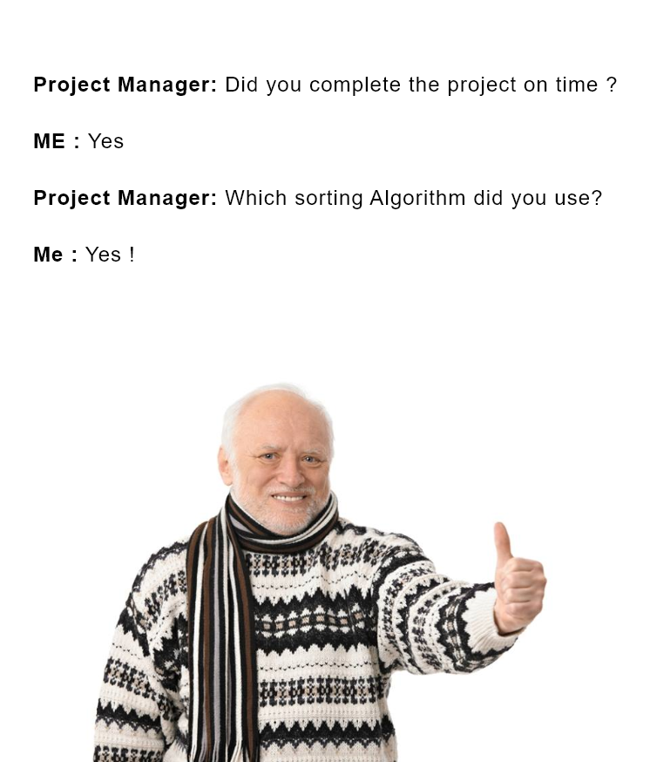







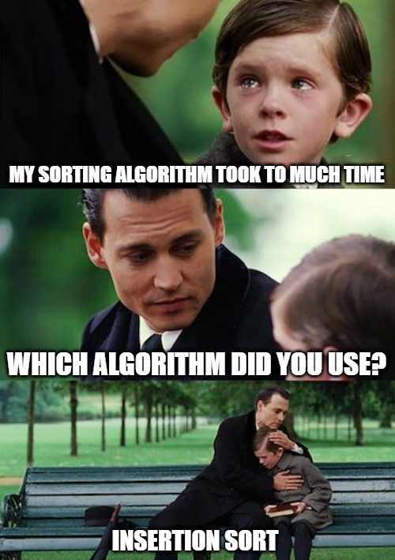









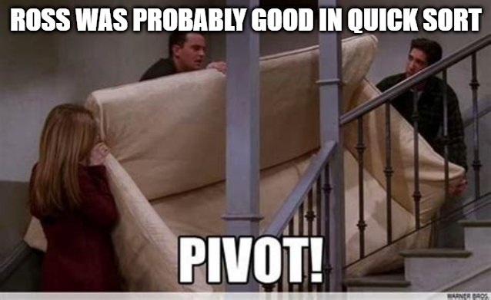

## Linked Lists

**Linked List is one of the most crucial topics which is easy once understood thoroughly. This topic is very important for both your college semester examinations as well as for placement purposes.**